***Installing ROS Noetic on last Ubuntu 20.04 OS***

The first step we should install the latest LTS version of Ubuntu 20.04 on the Virtual Box from this website (<https://ubuntu.com/download/desktop>) .

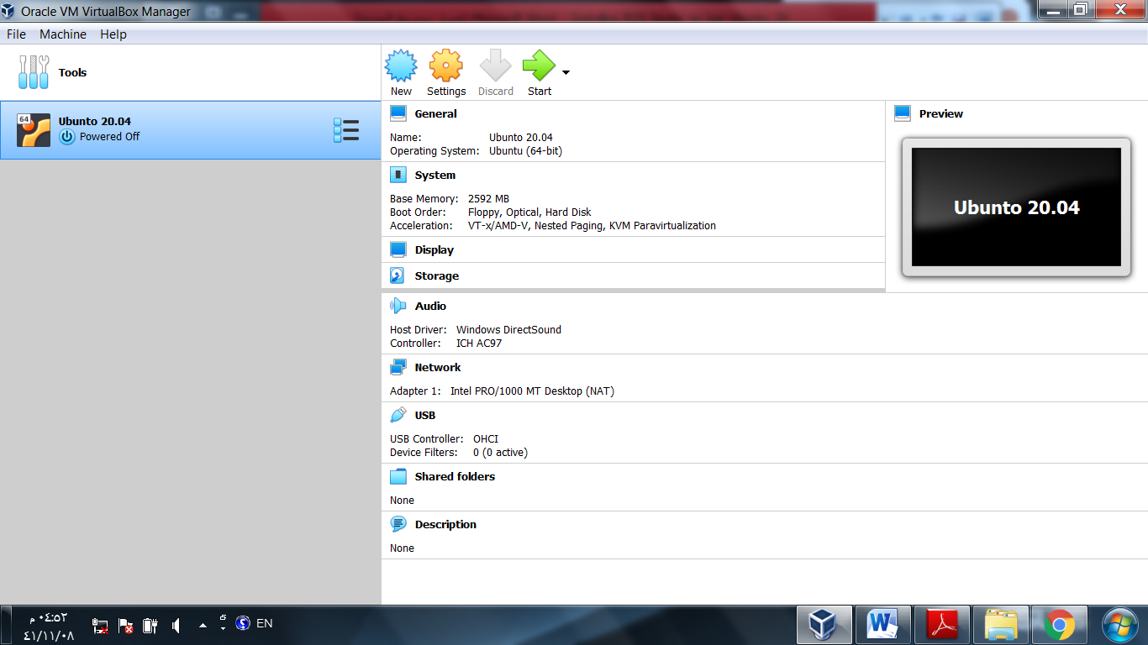

After we finished installing Ubuntu 20.04 , open the terminal and copy this command (wget -c https://raw.githubusercontent.com/qboticslabs/ros_install_noetic/master/ros_install_noetic.sh && chmod +x ./ros_install_noetic.sh && ./ros_install_noetic.sh )

And past in your terminal . then click Enter …

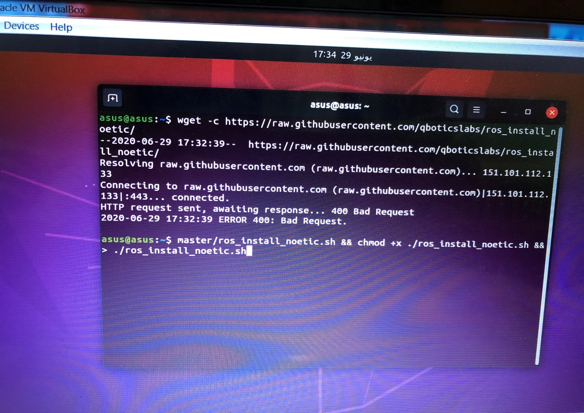

Then enter your password and click Enter .. and wait few minutes then choice 1, and click enter .



Wait until it finished installing desktop-full . after that ,

Write( rosversion –d) in the terminal to ensure that the system was installed in the correct way .

